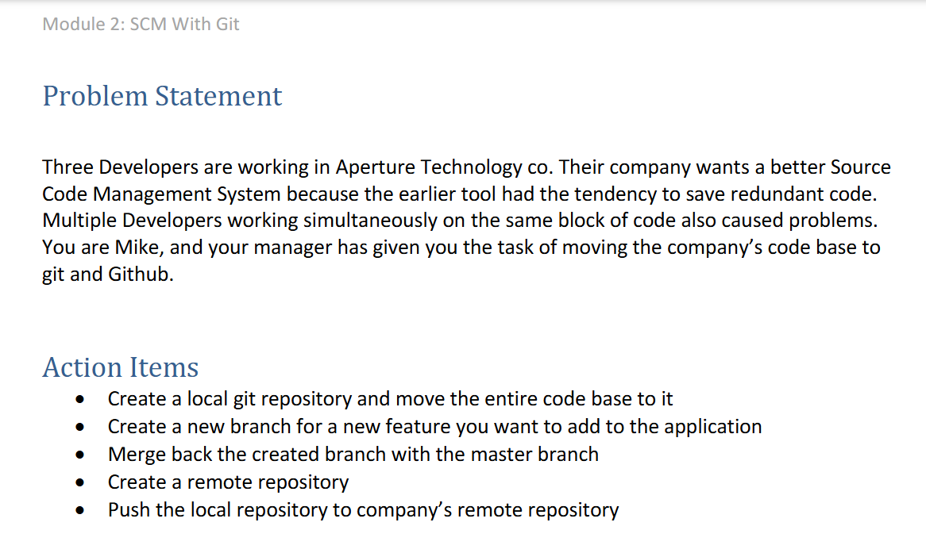

Solution:

1. Creating a local git repo and moving the codebase to it.

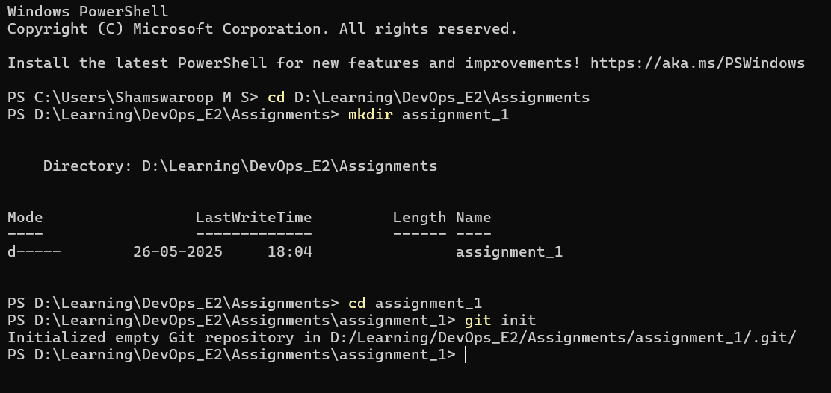

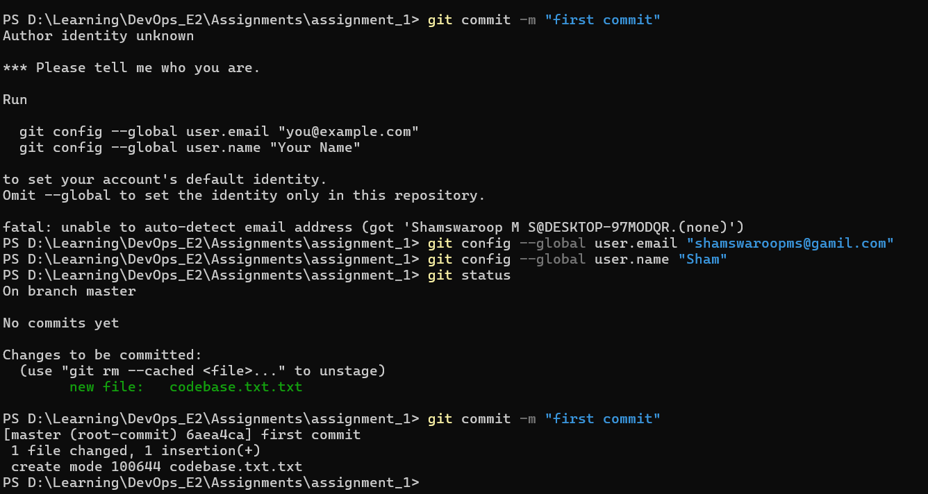



1. Creating a new branch for the new feature.



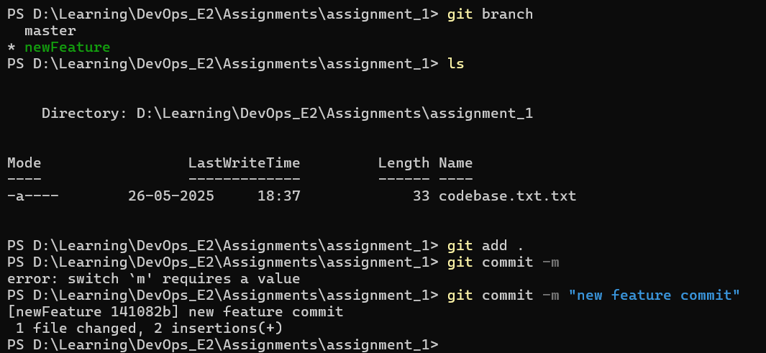

1. Merge back the created branch with the master.

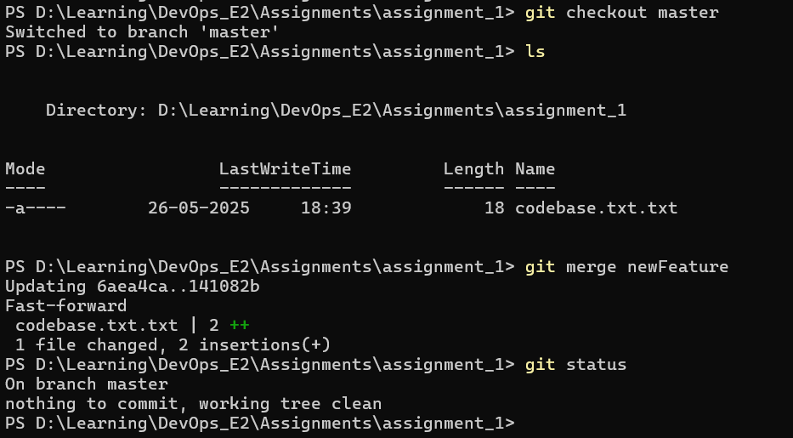

1. Creating a remote repo

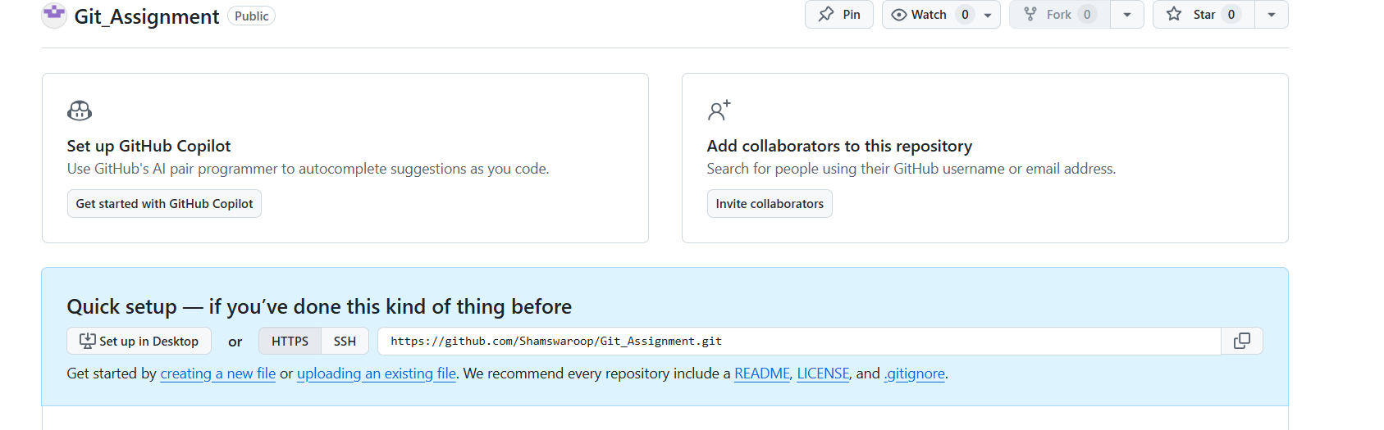

1. Push the local repo to remote repo

